1. Bài gốc https://vietnamnews.vn/talk-around-town/1802722/a-ha-noi-that-never-stands-still.html

A Hà Nội that never stands still
October 24, 2026 - 08:50

The bittersweet debate over the milk flower is not merely about loving or loathing a fragrance; it is about how a city preserves its collective memory without demanding that modern life stand frozen in time.
Thùy Linh
On an October evening, riding through familiar streets, one often recognises autumn from the scent carried on the breeze before even spotting the trees. The hoa sữa (milkwood flower) returns just as it always does – heady, lingering and heralding the first crisp days of the season.
To Hanoians, hoa sữa (the blossom of the milkwood, or blackboard, tree) is far more than just botanic greenery. It is woven into the city’s collective memory, passed down through generations and immortalised in poetry and song.
In the poignant verses of Em Ơi, Hà Nội Phố, poet Phan Vũ evokes the scent of milkwood flowers alongside ylang-ylang as an indispensable part of the capital’s soul: "My dear, Hà Nội's streets/ We still have the scent of ylang-ylang/ We still have the scent of milkwood flowers."
Renowned songwriter Trịnh Công Sơn, in Nhớ Mùa Thu Hà Nội (Remember Hà Nội's Autumn), likewise wove the blossoms into melodies synonymous with the capital's autumn: "Hà Nội in autumn, autumn in Hà Nội/ The season of milkwood flowers returning, perfuming every gust of wind."
From the written page to musical notes, the blossom has become a cultural symbol. A single whiff is often enough to conjure up memories of an old street corner, a bygone chapter of youth or a companion who once walked beside us on a distant autumn night.
Yet beyond the romance of literature and song, the overpowering fragrance of milkwood flowers is not always greeted with the same affection. While some eagerly await the blooming season like an annual rendezvous, others hurry through streets saturated with the suffocating aroma.
Historically, the tree has been part of Hà Nội’s urban landscape since the French colonial period, introduced alongside Western-style streets, parks and tree-lined avenues. Over more than a century, it gradually became embedded in the everyday lives and memories of the city's residents.
Between 1990 and 2010, however, mass planting became a trend along newly developed thoroughfares such as Nguyễn Chí Thanh, Trần Duy Hưng, Lê Đức Thọ and Hồ Tùng Mậu.
Published records indicate that Hà Nội currently has around 14,400 milkwood trees on its streets and in urban areas. More tellingly, urban green space per capita in the inner districts stands at just 2–3 square metres, far below the international benchmark of 9–12 square metres.
These figures reveal an issue that goes well beyond personal preferences for a particular floral scent. When a single species is planted in dense clusters, its natural characteristics can quickly turn from a pleasant feature of the urban landscape into an environmental burden during peak bloom.
The tree is hardly to blame. What demands scrutiny is how we select, space and manage urban greenery within an increasingly crowded metropolis.
One commuter who frequently crosses Nguyễn Du Street said: “The milk flower gives Hà Nội its distinctive character, and its autumn fragrance is unmistakable. But when planted too densely, blooming all at once, the scent turns suffocating. Some may love it, but others simply cannot bear it.”
Writer Nguyễn Ngọc Tiến once noted that the milkwood flower is "suffering an unfair verdict", arguing that the crux of the issue lies in urban planning rather than the fragrance itself. His observation offers a compelling perspective: at times, what people protest is not the cultural symbol itself, but thoughtless way that symbol has been imposed on everyday life
In response to public feedback, municipal authorities have ordered a review to thin out areas where the trees are too densely planted and replace some of them with other species. As an immediate measure, crews have trimmed flower clusters on almost 1,000 trees across 13 streets. The instructions are clear: no indiscriminate cutting of tree crowns, no excessive pruning and no unauthorised chemical inhibitors.
“To know whether autumn has arrived, you only need to see and smell the milkwood flowers," said Hạnh Thu, a resident of Cửa Nam Ward. "I admit the scent can be cloying at times, but it is tied to so many memories that it is the defining soul of Hà Nội's autumn. Moving these trees away would truly be heartbreaking.”
Naturally, making adjustments should never mean turning our backs on the past. Centuries-old trees along historic streets, those that have entered literature and anchored the memories of generations, retain their timeless value.
Yet deeply felt memories, no matter how profound, are also deeply personal. The nostalgic affection of one group cannot automatically serve as justification for an entire population to endure daily discomfort.
Urban identity is not a static photograph. Viewed in this light, the story of the milkwood flower belongs to a much broader vision: cultivating a diverse green canopy that strikes a balance between shade, aesthetics, ecological health and the practical needs of residents.
A liveable city requires more than symbols to remember; it requires functional spaces where people can live together comfortably. Selective preservation is, therefore, a matter of balancing cultural heritage, municipal responsibility and every citizen's right to a pleasant living environment.
October will pass, and the milkwood blossoms will fade with the chilly winds, making way for future autumns yet to come. What needs preserving is perhaps not every single tree on every single corner, but the ability of that scent to evoke Hà Nội without becoming a burden to those who call this city home.
Memories, after all, only have true meaning when they coexist with the present, not when they force life to stand still. — VNS

2.https://www.theguardian.com/film/2026/nov/02/rhys-ifans-laura-linney-onwards-sideways-film-interview-parkinsons-paul-mayhew-archer
Interview

‘We both know how we feel about death and dying’: Rhys Ifans and Laura Linney on their brutally honest Parkinson’s drama
Craig McLean
Written by Vicar of Dibley co-creator Paul Mayhew-Archer, who has the disease, Onwards and Sideways sees the actors play a couple who bond over their diagnoses – a devastating subject but laced with humour too, they say
Mon 2 Nov 2026 08.00 GMT

A
head of production on their first job together, Rhys Ifans and Laura Linney didn’t undergo the standard “chemistry read” to make sure they got on. Which is remarkable, given what their characters would have to do to each other in Onwards and Sideways.
In the Norfolk-set BBC film directed by John Madden (Shakespeare in Love), Ifans would have to nearly throttle Linney while in the grip of night terrors, she’d have to collapse in his arms in a weeping mess having bankrupted herself with a gambling addiction; both situations arising from the neurological condition afflicting their characters: Parkinson’s disease.
But despite being thrown into the deep end in this hugely emotional, often hilarious film, both actors acknowledge an immediate feeling of safety around each other as they embarked on a project that would require them to strip themselves bare. “It’s odd,” says Ifans, “you learn so much about each other so quickly. I couldn’t tell you what kind of car Laura drives. What her home looks like. But we both know how we feel about death and dying.”
/
0:10
Americans head to polls in midterm elections seen as referendum on TrumpAmericans head to polls in midterm elections seeas referendum on Trump
Read Linney, 62, is a triple-Oscar-nominated star with a diverse array of roles on her CV, from her breakthrough in The Truman Show (1998) onwards through Clint Eastwood’s Mystic River and Richard Curtis’s Love Actually (both 2003), then the TV series Ozark and The Big C. Ifans, 59, frankly burstthrough in 1997’s Twin Town, AKA the “Welsh Trainspotting”, and went on to play Hugh Grant’s scraggly flatmate Spike in Curtis’s Notting Hill (1999), Daniel Craig’s stalker in Enduring Love (2004) and drug smuggler Howard Marks in Mr Nice (2010).
Divergent backgrounds, then. But equally time-served, too. So the actors were able to dive in, no chemistry read required. They did, though, do dance classes. They waltzed together in London, and separately nearer their respective homes, the better to understand one popular form of recreational therapy for people with Parkinson’s. In Brooklyn, Linney was introduced to David Leventhal at the Mark Morris Dance Group. He runs a programme there called Dance for PD.
“That’s the mothership of this wonderful organisation that now has offshoots all over the world, including here,” the New Yorker says when she, Ifans and I meet in the central London offices of the producers behind Onwards and Sideways. Both are dressed casually and low-key, each clearly easy in the other’s company, their conversation frequently erupting into gales of laughter.
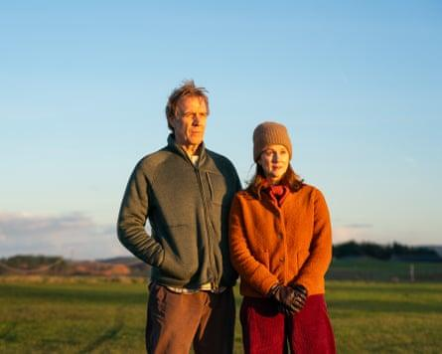
View image in fullscreen
Ifans and Linney in Onwards and Sideways. Photograph: Jonathan Birch/BBC
“I spoke with David for a long time – and then I learned that Juilliard has classes for this once a week,” Linney says of the acting school that’s her alma mater. “So I just started hanging out there. It’s incredibly moving what the arts will do,” she says – in this case, how dance and music could relax people grappling with a condition that, among its 40-plus symptoms, causes uncontrollable shaking, stiffness of gait and involuntary freezing in doorways and thresholds. “How brave it makes people. How it opens up the imagination, and then the body follows somehow, when it shouldn’t. And the difference between someone moving in a dance class and then, when the music stops, to see what happens to their bodies – it’s shattering in a good and a sad way. So … it gets right to the bone of things.”
Ifans, meanwhile, attended weekly sessions with a group who meet in Pontio, an “arts and innovation centre” in Bangor, north-west Wales. “There was a harpist accompanying the dance,” says the Pembrokeshire native. “Then there was a support dog running around the room who happened to be a sheepdog.”
“Herding!” adds Linney, laughing.
“It was peak Welshness!” acknowledges Ifans, to hoots all round. Then, quietly again: “They were so inspiring, these classes. And a great leveller. You’d be sitting next to a nuclear scientist and a school cleaner. Both dancing to the same tune and wrestling with the same diagnosis.”
The writer of Onwards and Sideways is Paul Mayhew-Archer. He’s an actor, writer – he co-created The Vicar of Dibley with Richard Curtis – and accidental activist. The 73-year-old is a founder member of the Movers and Shakers podcast, which raises both awareness and laughs, alongside fellow “Parky people”, including journalists Jeremy Paxman and Mark Mardell. He was diagnosed with the disease at 58, with the canary in the coalmine, symptoms-wise, being that “my handwriting was very small and unclear”.
His experiences directly inform the experiences of the fiftysomething characters played by Ifans (Tony, a teacher) and Linney (Emma, a musician). They also, full disclosure, inform my writing of this feature: my dad has Parkinson’s and I’m in the age bracket Mayhew-Archer was when he was diagnosed. My handwriting is appalling.
True to Mayhew-Archer’s mission, Onwards and Sideways is painfully, honestly funny. The scene where Rory Kinnear’s doctor rather cavalierly informs Tony that he has the condition features a joke lifted from Mayhew-Archer’s own diagnosis.
“My neurologist told me one of the symptoms is the difficulty of smiling, and that I seemed to have difficulty smiling,” Mayhew-Archer relates to me when we meet on another day in the same office. “And I said: ‘Well, that could be because you just told me I’ve got Parkinson’s.’ As soon as I said that, I knew I wanted to be funny about Parkinson’s, because I saw no point in being serious.”
There’s a mercurial element to this illness – it’s bespoke. No one has the same Parkinson’s
Ifans – who’s been staunchly committed to this project for the duration of its lengthy gestation, stretching back pre-Covid – seconds that emotion. “I loved the way Paul’s story about a life-changing diagnosis was handled, funny and devastating all at once. My attraction to it was also that I have friends and family who’ve been impacted by Parkinson’s. That gave me a fast track into the telling of a story like this.”
“You don’t have to scratch very far to find someone somewhere who knows someone who has Parkinson’s,” echoes Linney of a condition that, in the UK, 166,000 people are living with, with one person being diagnosed every 20 minutes according to Parkinson’s UK. “I certainly have friends who do.”
To “act” Parkinson’s, Ifans and Linney were aided by the Neuro Heroes, “remarkable women who do physio for people with Parkinson’s and various related conditions”, says Linney. “They helped us with our basic understanding of Parkinson’s, and then also the physicalisation. [Because there’s] a mercurial element to this condition – it’s bespoke. No one has the same Parkinson’s.” Or even the same side-effects from the drugs prescribed to help manage the incurable condition: they can cause increased libido, appetite, and compulsive spending and gambling.
“Parkinson’s was like a physical dialect for us,” continues Ifans. “We had to learn its physical language. They [the Neuro Heroes] could say what was happening at the muscular level, or the skeletal impact, of Parkinson’s. But we needed poetry to understand what that felt like. Whether it felt like moving through tar or sand. Just to be able to arrive at an image that you could apply to the body, that you could take with you to set each day, to help you achieve the shapes and positions that Parkinson’s puts people in.”
And those people, ultimately, were always in the actors’ minds. Mayhew-Archer knew the film had to honour those with the condition, but that that noble aim did have its bluntly practical limits. “We knew we couldn’t cast people with Parkinson’s in those two central roles,” he says. “Partly because Laura’s character has [a medical procedure] done which means she stops doing certain things. And it would be very hard for people with Parkinson’s to stop doing some things!” he adds with a laugh. “Once you start freezing, you can’t stop!”
“We had the added responsibility in getting Parkinson’s right,” says Ifans. “Not just right, but bang-on. Because there’s a whole demographic watching that deserves to be represented. That was the scary bit, wasn’t it?”
Linney, staring intently at her co-star across the table, nods. It was, she says, fundamentally about “doing it justice”. And then, “the possibility of failing at that?” says Ifans. “Huge responsibility. That brought us closer together. That’s the stuff that woke us up at night.”
When we meet, Linney is about to be unveiled as one of the cast of DC superhero TV series Lanterns. She’s a Guardian of the Universe, “or so I’ve been told”, she says with spoiler-savvy diplomacy. “But a green beam might come down and evaporate me if I utter a word!” She’s also two weeks into filming, alongside Colin Firth and Julianne Moore, Comfort and Joy (formerly The Joy of Sex), a romcom about the north London throuple who helped produce Alex Comfort’s groundbreaking 1972 illustrated sex manual. So, another unconventional midlife drama but lighter, certainly, than Onwards and Sideways.
“There was something about this world of Parkinson’s that forced me to be very present in a way that I normally am not, particularly while working,” she admits. “It forced me to be over my skis a bit. And off-balance, and vulnerable, and experiencing things in very different ways. “This movie rearranged my cellular structure!” she adds, beaming in gratitude. “Most movies don’t do that. I love my work. But very few experiences have literally rearranged my soul. This one certainly did.”
As for Ifans, this year we’ve seen him alongside Anna Maxwell Martin in Apple TV’s cold war-era sci-fi thriller Star City. When I meet him, he’s just been beheaded on House of the Dragon. Onwards and Sideways, in stark contrast, is acting in the raw, with no high-concept narrative or CGI to hide behind. Acting of a different order.
“Yes. You can have spaceships, lunar landscapes, swords and castles, but you ain’t gonna have a co-star like this,” Ifans says, beaming at Linney. “That’s where the money is. Not the coin … That’s why we go to work. As Laura says: all these [roles] are different and thrilling and enjoyable in their own way. But this film is particularly nourishing.”
Having seen Onwards and Sideways in the company of my mum, who cares 24/7 for my dad, I couldn’t agree more. We watched it bathed in both tears and smiles. It’s a beautiful achievement; empowering, educational entertainment, and Ifans and Linney deserve all the credit in the world for how they’ve portrayed the multiverse of Parkinson’s. I would send them a personal note to thank them for what they’ve done for those with, and connected with, the disease. But I’m not sure they’d be able to read my handwriting.
Onwards and Sideways is in UK cinemas from 6 November, and on BBC One and iPlayer later this year.
… we have a small favour to ask. Tens of millions have placed their trust in the Guardian’s fearless journalism since we started publishing more than 200 years ago, turning to us in moments of crisis, uncertainty, solidarity and hope. More than 1.5 million supporters, from 180 countries, now power us financially – keeping us open to all, and fiercely independent. Will you make a difference and support us too?
Unlike many others, the Guardian has no shareholders and no billionaire owner. Just the determination and passion to deliver high-impact global reporting, always free from commercial or political influence. Reporting like this is vital for democracy, for fairness and to demand better from the powerful.
And we provide all this for free, for everyone to read. We do this because we believe in information equality. Greater numbers of people can keep track of the global events shaping our world, understand their impact on people and communities, and become inspired to take meaningful action. Millions can benefit from open access to quality, truthful news, regardless of their ability to pay for it.
Whether you give a little or a lot, the support of readers like you from Vietnam will power our reporting for the years to come.
We value whatever you can spare. Your support enables greater investment in our most crucial, fearless journalism. Thank you.
3.. Meet the educators using science to teach kindness (Quỳnh)
https://www.positive.news/society/meet-the-educators-using-science-to-teach-kindness/
How would our world look if the next generation became leaders in kindness? These teachers are using science to help children understand what happens to our brains when we’re kind
Science has shown that acts of kindness – such as helping someone in need, or giving to charity – improve our health, help build better relationships, and can even be contagious. Such acts promote the production of ‘feel-good’ chemicals like oxytocin, serotonin and dopamine in our brains, and possibly even give us a ‘helper’s high,’ scientists say.
That’s why the charity kindness.org is keen to promote kindness, and an understanding of the science behind it, in schools. The result will be happier students and more caring classrooms, they say – and society as a whole stands to benefit.
Its Learn Kind curriculum looks at the science of kindness, along with the development of skills such as self-awareness, empathy and emotional literacy. The pilot began in 2020, when it was taught in 15 countries, including the US, the UK and Thailand, reaching more than 38,500 students globally. Deemed a success, Learn Kind has now been adopted by 260 schools worldwide.
“Kindness impacts our physical, emotional and mental health,” says Rebecca Reed, director of programmes at the charity. “An entire year of students experiencing a culture of kindness [could impact] communities, cities or countries.”
Positive News spoke to some of the educators involved in the pilot to find out more.

Empathy via emojis
Bradley Evans is a teacher and counsellor at T.H. Rogers school in Houston, Texas.
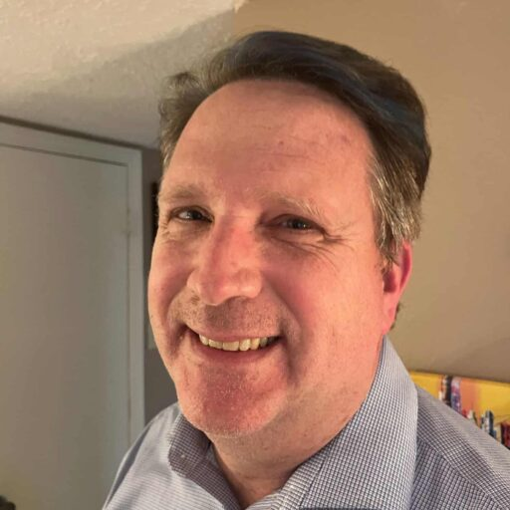
My students are very academically driven, but not very socially driven,” says Evans, who teaches children aged between five and 12, who have been identified as exceptionally bright. “So, I liked the programme, with its scientific background.”
Once he had the curriculum, Evans jumped right in with a lesson about emotions. Learn Kind has its own set of emojis, showing a wide range of expressions, and the students were asked to identify the emotions behind them. For example, one emoji features a squiggly mouth. “Some said it was confused, others said it looked upset,” Evans says. “Every child interpreted it differently, but they could all agree it was disturbed in some way.”
I believe all kids have kindness in their heart, and this lesson brought that to the surface
Then he asked students what they looked like when they felt confused. “They were able to say: ‘My eyes tighten up and my teeth clench’,” he recalls. “This was one of the best lessons,” Evans enthuses, adding that the exercise enabled his students to recognise how their peers are feeling, even if initially they were a bit hesitant.
At the end of the programme, he encouraged his students to “catch each other being kind”. When they witnessed an act of kindness, they jotted down a note, saying what they saw. Kind acts could be as simple as cleaning up the classroom, or helping someone to pick up something they had dropped. The names of the students who were “caught being kind” were then listed in the front foyer of the school, to amplify their action. “I believe all kids have kindness in their heart, and this lesson brought that to the surface,” Evans says.
The curriculum has had a big impact on his students. “They’re making more friends and keeping them,” he reports. “They’re more compassionate: they’re not putting each other down, and they’re better listeners.”

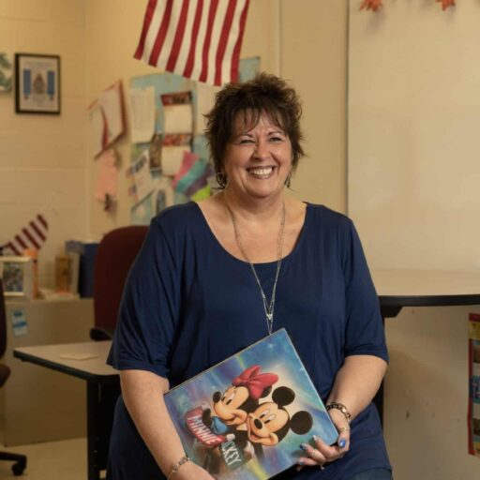
Activating a natural curiosity
Doretta Martelli teaches 11–14-year-olds who have developmental and social disabilities, at Bunker Hill middle school in Sewell, New Jersey.
Kindness has always been a passion of mine,” says Martelli. “My mum hammered it into me when I was young.” So she jumped at the chance to teach the Learn Kind curriculum to her students.
Martelli is a special education teacher, with students aged 11–14 who, she notes, don’t always get a lot of nurturing at home.
Initially, there were eye-rolls and hesitancy. But the scientific focus of the lessons was able to draw in even the most sceptical of students
She particularly enjoyed a lesson about empathy, that centred around role play. For example, one child was asked to play someone who had no one to sit with at lunch, and another was asked to think about what they might say to them.
Initially, there were eye-rolls and hesitancy, Martelli admits. But the scientific focus of the lessons – activating kids’ natural curiosity by looking at kindness throughout history, for example – along with the activities, was able to draw in even the most sceptical of students.
To round off the programme, the children conducted their own scientific ‘kindness experiments’ – documenting how carrying out kind acts made them feel. For example, one student chose to make a Skype call to his grandma. Another decided to bake cookies with her sister. Perhaps unsurprisingly, both documented feeling good afterwards.
The students seemed to take the lessons to heart and referred back to them over the rest of the year, Martelli says. She thinks the programme has the potential to create a better world. “I’ve seen so much change in the world over the course of my 60+ years. Our society has progressed in many areas, but it would appear that the basic tenet of kindness has been pushed to the back of the shelf. We are overly concerned with academic advances and technological innovations. But kindness? It’s vital for the future success of society.”
Main image: Paolo Jay
4. https://www.positive.news/environment/three-people-who-have-jobs-in-nature/

Meet three people who make a living by showing kindness to the planet (Quỳnh)

Being kind to the planet pays, especially for these three individuals, who talk to Positive News about their jobs working with nature
Working to protect the environment is rewarding, despite its challenges. Positive News meets three women whose careers are all about being kind to nature.

Carolina Pinto
Brent rivers and communities officer at Thames 21, a charity that works across London to improve rivers for people and wildlife
“I grew up by the sea in Brazil, so I always felt a connection with nature – I was always at the beach, looking at animals there. Once I began studying environmental science at university I just fell in love with it, and I did my master’s in freshwater environments.
There’s no such thing as an average day or week for me. Some of my work is very hands-on, such as installing large pieces of wood in the river to restore habitats for fish and other wildlife there, which also helps filter the water and reduces flood risk. I monitor water quality and biodiversity, and I’m now also looking to work with local artists and storytellers.
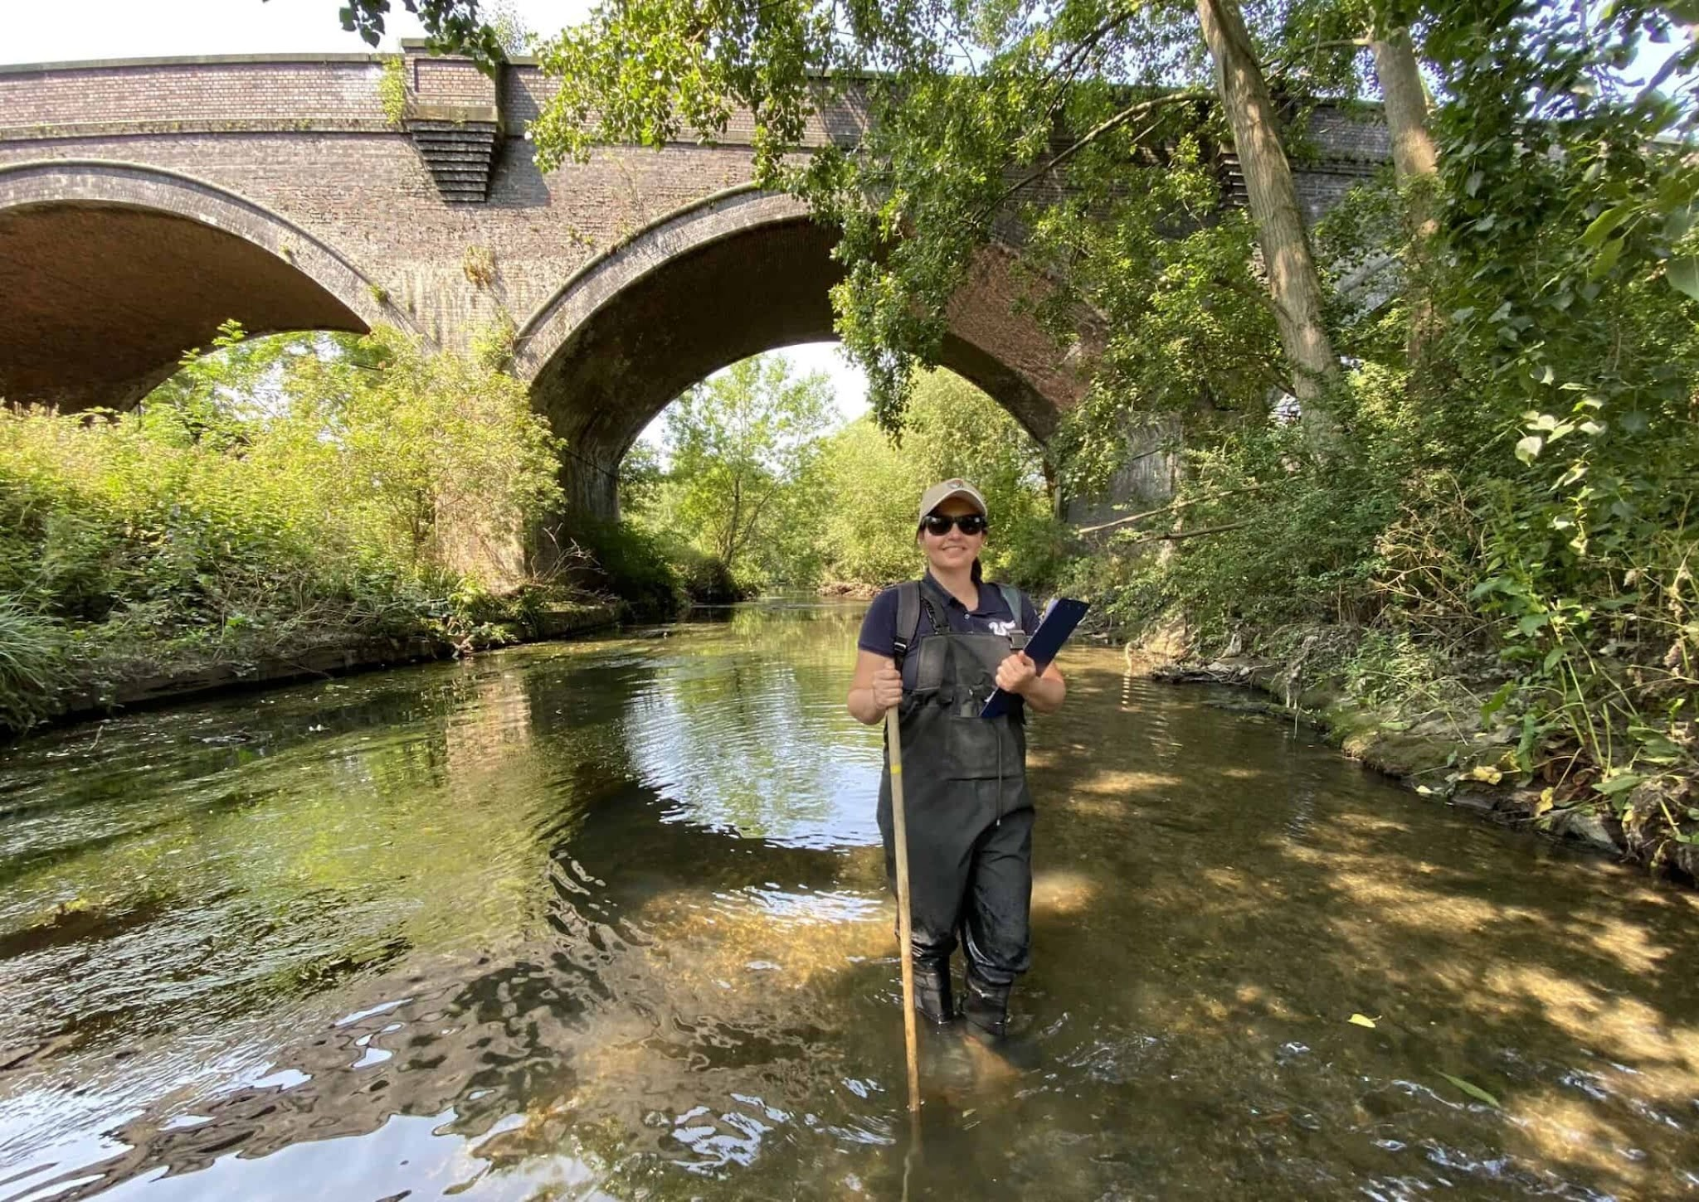
Current affairs: Carolina Pinto can sometimes be spotted wading through a river
Community engagement is a key part of my job: we teach local people how to look after their waterways, to increase their sense of ownership and belonging. The benefits are huge. I’ve taken teenagers who’ve never seen a river before on a tour – they’re amazed by the sound of the water, the birds and the fish. I’ve also worked with a charity to help people with mental health issues experience the river, and it’s rewarding to see what a powerful effect nature has on their wellbeing.
Seeing wildlife returning thanks to our restoration work is exciting. I was so surprised to see a big eel recently in a section of the river that’s suffered from pollution – I could hardly hold my phone steady enough to take a picture.
It’s been challenging trying to get local people involved in volunteering in one of the poorest boroughs in London, with residents facing many pressing issues. But since the pandemic, there’s been more interest – I wonder if people want to come out more to do something for their environment. The message I want to get across to them is: this is your river, for you to enjoy.
Volunteer for a local conservation charity if you can – find out if there’s a river restoration project near you. And wear a reusable cloth mask, not a disposable one!”

Georgie Bray
Manager of the RSPB-owned Hope Farm, Cambridgeshire
“I’ve always been interested in animals and conservation. I grew up on an arable farm, then studied biology at university and did a master’s in zoology. I became increasingly interested in conservation and agriculture, and how the two can knit together – as well as the obvious fact that they don’t always knit together well, with aggressive farming having a negative impact on wildlife.
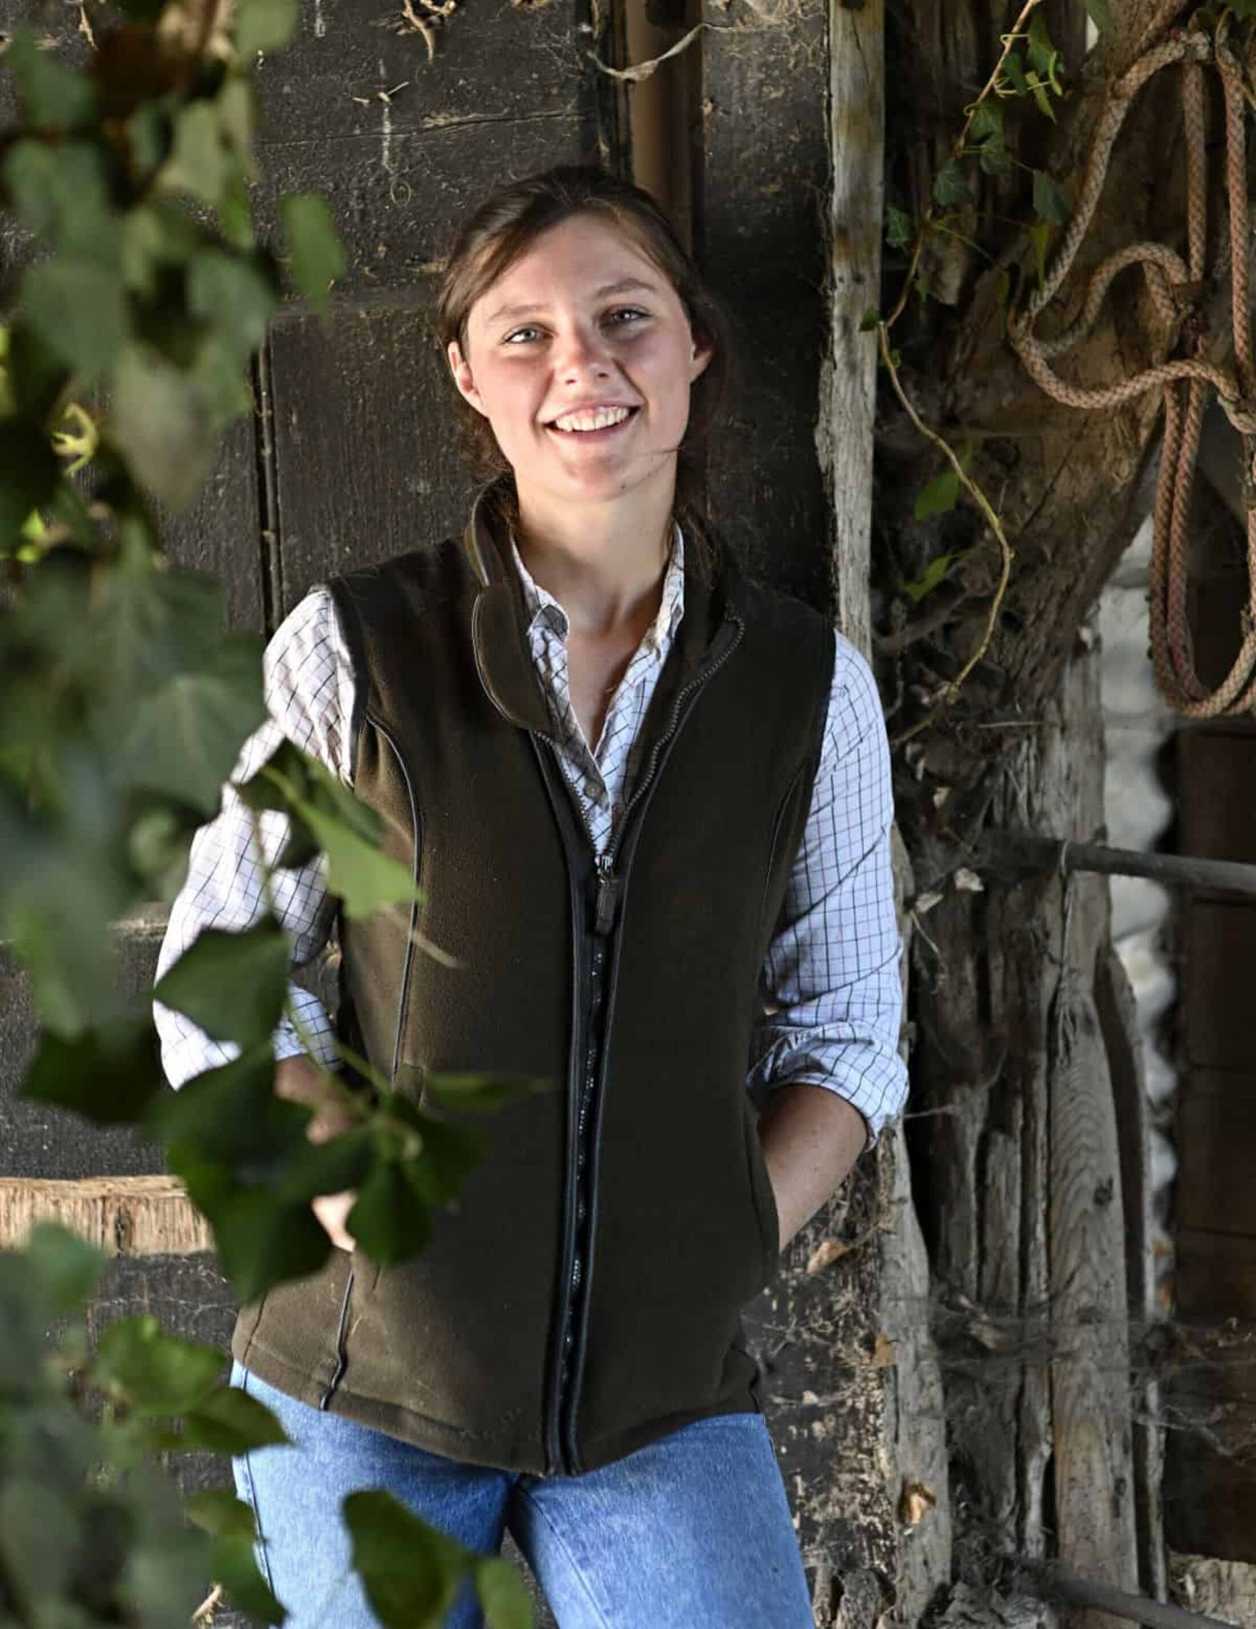
Georgie Bray manages Hope Farm, which is leading the way on wildlife-friendly agriculture
The RSPB bought Hope Farm in 2000 to research kinder farming methods and show that nature-friendly farming can turn profits. There’s been a huge improvement in wildlife since then, with a more than 400 per cent increase in butterfly numbers. The farm now grows peas, beans, winter wheat and spring barley, as well as millet, which is processed and sold as bird food.
I’ve managed the farm since 2016, doing everything from research, to making sure the bird seed mixes and wildflower margins are in good condition and providing the wildlife with what they need.
Someone once said we need to stop treating soil like dirt, and that’s true. We need to treat it with kindness, like the living thing it is, and healthier soil is more resilient to the extreme weather that comes with climate change. It’s not the minerals – the dead stuff – in the soil that help you grow crops so much as the organic matter: the bacteria, the fungi, the worms, the insects going right the way up the food chain.
There’s been a huge improvement in wildlife, with a more than 400 per cent increase in butterfly numbers
And if you have all of that biology alive, that’s a basal [bottom layer] food source for wildlife as well. Whereas if you drive a big plough through an ecosystem, it’s going to mash it up and the things that live in it won’t be happy. Instead, we grow crops with root systems that keep air pockets in the soil, to stop it getting too compacted, rather than cultivating it every year. It sounds fairytale-like to say that if you look after the wildlife, it will look after you, but there’s actually a lot of science behind that.
How to be kind to the environment? Buy wildlife-friendly local produce. Farmland covers three-quarters of the UK, so the more you can support sustainable farming, the better. Take an interest in nature, download a birds app, take binoculars on your walks – the more you appreciate your environment, the more you’ll want to conserve it.”

Gala Bailey-Barker
Farmer at Plaw Hatch Farm, Sussex
“Growing up, I always wanted to be a farmer. When I was little, I read Dick King-Smith’s books about a girl called Sophie who wanted to be a ‘lady farmer’, and we often visited family friends in Wales who had sheep. I’d help them bottle-feed the lambs.
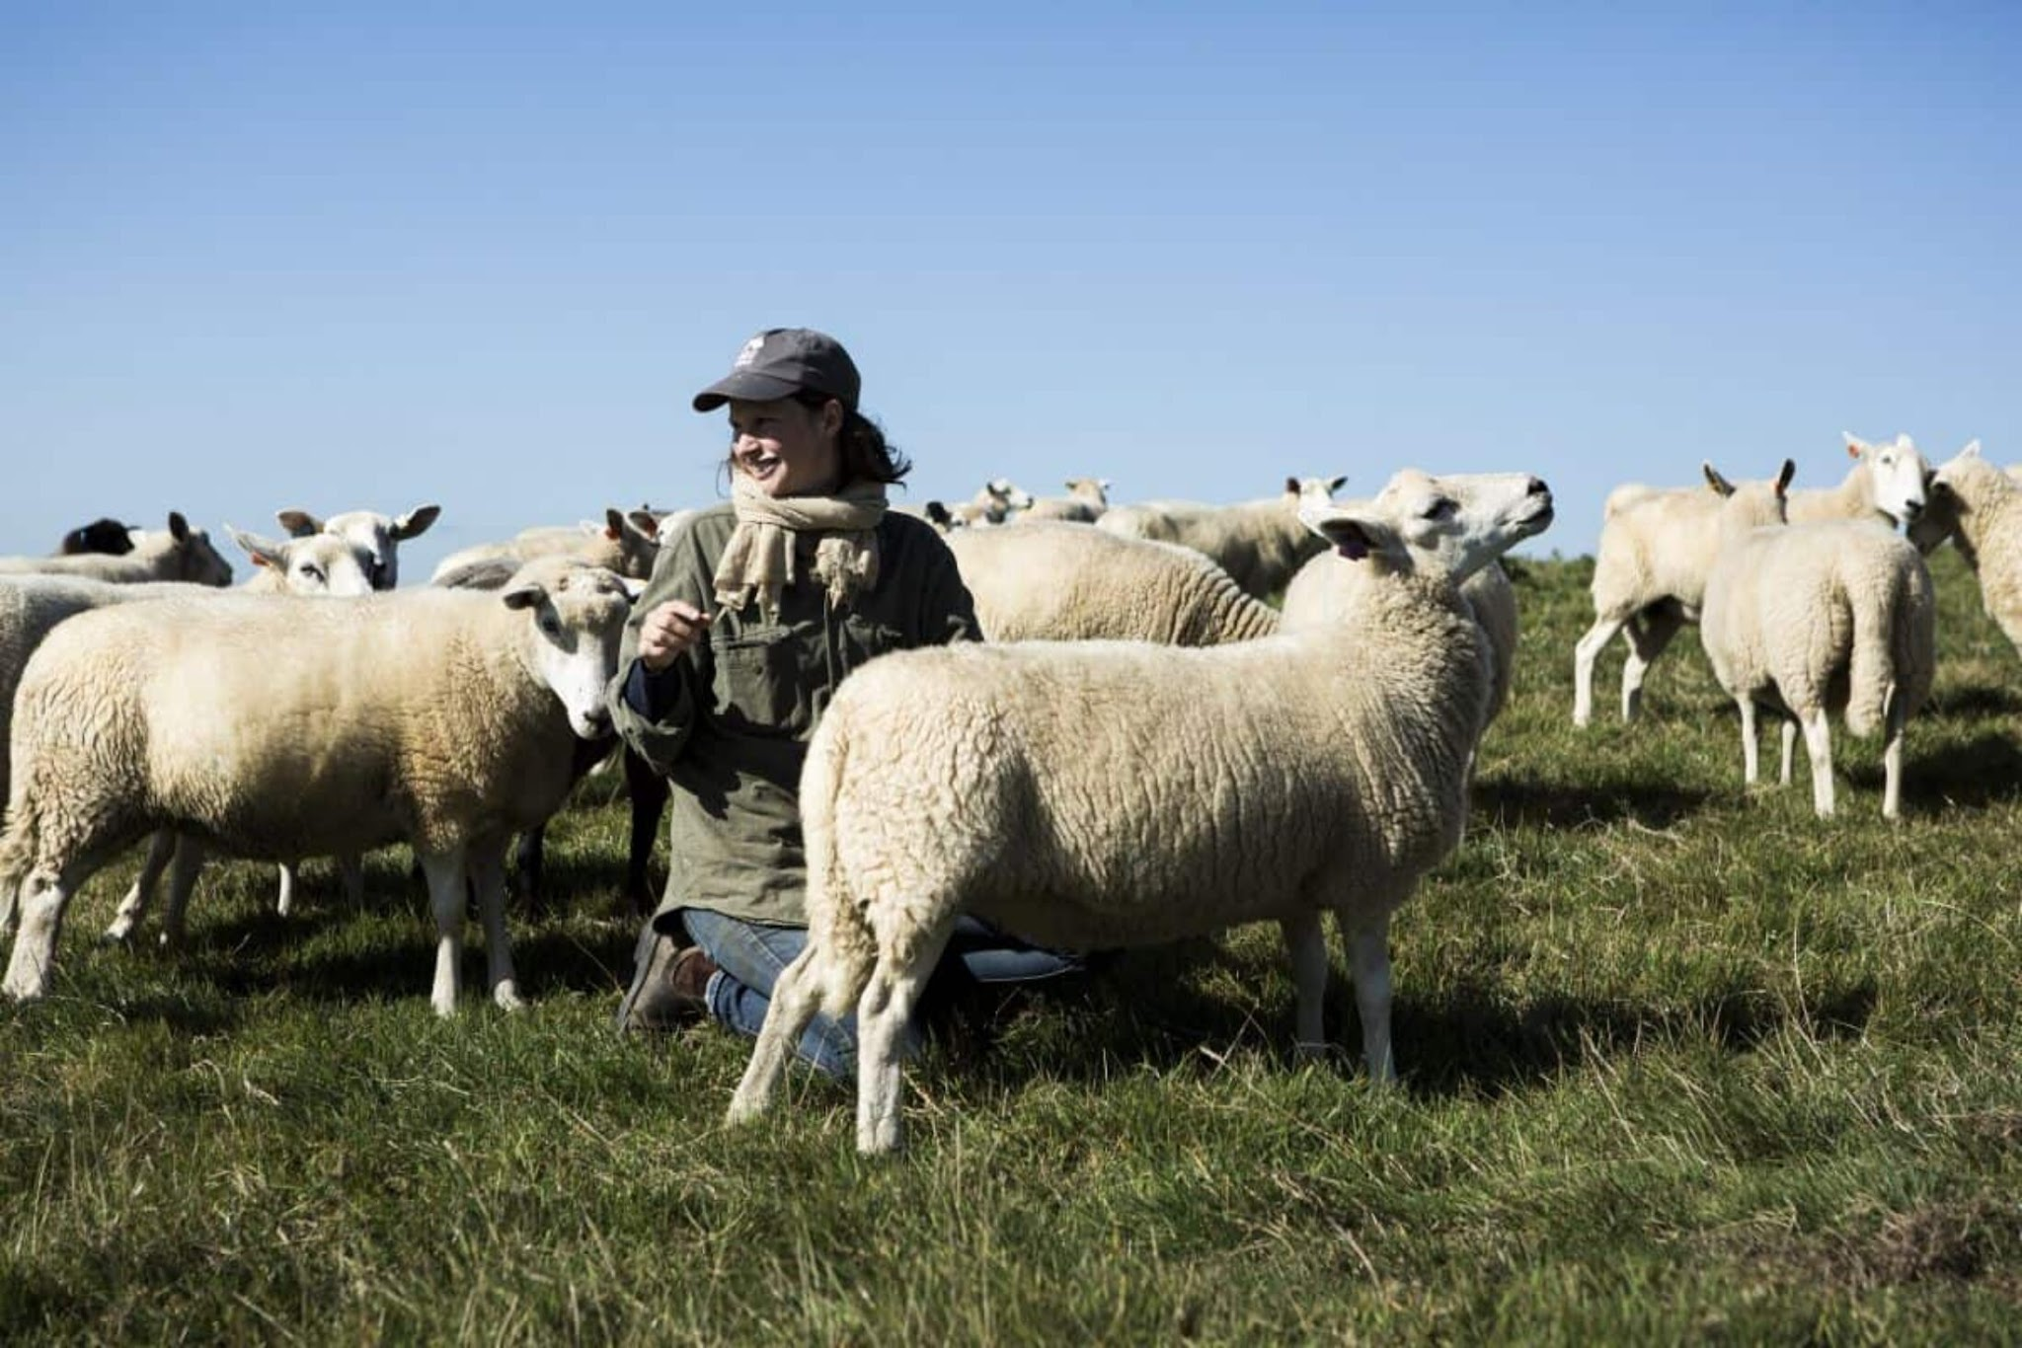
Gala Bailey-Barker has been with her flock for eight years, forming close bonds with the animals
Now I look after sheep and chickens. Biodynamic farming is about trying to create a closed system, where a whole cycle is happening. We aim to rely only on our own animals to fertilise the ground rather than buying any compost, and use as much as possible from our own crops to feed the animals.
Lambing in the spring is incredibly hard work. I get up at 5am and can be out until really late, but I love it. Seeing all that new life come into the world is just amazing – we get about 100 new lambs in two weeks. The pregnant sheep have a strong maternal instinct just before they’re about to give birth – sometimes you have to stop them from stealing other ewes’ lambs.
I get up at 5am and can be out until really late, but I love it. Seeing all that new life come into the world is just amazing
When the ewes give birth, I watch carefully to see if I need to intervene. The lambs are really playful – they skip around and have lamb races. Their mums shout at them in the evening to settle down, because they can’t grab them in the way that human parents can. I bottle-feed lambs who’ve been rejected by their mothers, and those ones usually remember you forever, though they go through a teenage phase where they’re a bit more aloof.
Buying organic food – or biodynamic food, if you can get it – is one way to be kinder to our environment. Visit a local farm if you can, and buy their produce. And avoid fast fashion – it’s so damaging for the planet.”
Main image: Carolina Pinto pictured working in the field

5. https://www.theguardian.com/tv-and-radio/2026/nov/05/rory-kinnear-father-roy-death
Interview

‘I was given the big picture early’: Rory Kinnear on love, drama – and how his father’s death changed his life
Simon Hattenstone
When Kinnear was 10, his beloved father Roy died in an on-set accident. This affected how he now approaches his work as an actor, and also his understanding of life’s most important questions

Thu 5 Nov 2026 05.00 GMT
Share
Prefer the Guardian on Google
A
t first glance, Rory Kinnear is Mr Normal. Bald head, nice face, wholly unremarkable. As an actor, he’s not one for flashy tricks – no dramatic weight loss or gain, rarely disguising himself with prosthetics or CGI. Yet, somehow, whatever role Kinnear plays, he’s totally different.
So here I am in his dressing room at the Theatre Royal Haymarket in London, face to face with the man I’ve just seen on stage, and whose films and TV shows I’ve pored over for the past week, failing to recognise him. For starters, at 6ft, he’s taller than he should be. And more hench. And, actually, hotter.
He laughs, and says he’ll take that. “It’s amazing how many people ask me if I’ve lost weight, and say they thought I’d be smaller. They expect I’ll be just like my dad.” His father, Roy Kinnear, small and squat, was one of the most beloved and talented comic actors of his generation. He died at the age of 54 after being thrown from a horse while filming The Return of the Musketeers in 1988.
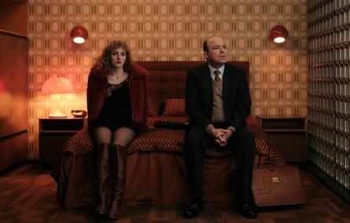
View image in fullscreen
With Ann Skelly in the BBC’s cold war thriller Honey, out later this month. Photograph: BBC/Sid Gentle Films
As for Rory, 48, he is one of the most beloved and talented actors of his generation full stop. He inhabits roles so subtly, making them his own with the tiniest twitch, pinched smile or throat flutter. While his father tended to play working-class characters, Kinnear is more likely to be cast as upper-middle class, very British, a wee bit constipated. But give him northern working class or solidly middle class and he’s equally brilliant. So for every Lord Lucan (ITV’s Lucan), Bill Tanner (MI6 chief of staff in the James Bond franchise) or Nicol Trowbridge (bombastic Tory prime minister in Netflix thriller The Diplomat), there’s self-made Dave Fishwick (Bank of Dave) or broken investment banker turned bicycle courier in Russell T Davies’s apocalyptic Years and Years.
0:04
/
0:10
US midterm elections 2026 live: Democratic lead grows in Mississippi Senate race as Republican blame game beginsUS midterm elections 2026 live: Democratic lead grows in Mississippi Senate race as Republican blame game begins
Read More

Today we’re pushing the posh on three fronts. There’s his press attache Graham Anderson in the BBC’s new comedic cold-war spy thriller Honey (an unofficial prequel to Killing Eve); a shockingly matter-of-fact neurologist in the affecting Parkinson’s movie Onwards and Sideways, and the celebrated economist John Maynard Keynes in James Graham’s play The Standard of Living. The first two parts don’t overly tax him, but as the Eton-educated, stiffly bohemian, ethically driven, voracious cottager who ended up marrying a prima ballerina and facilitating the NHS, he is fabulously nuanced. I never thought economics could make me cry.
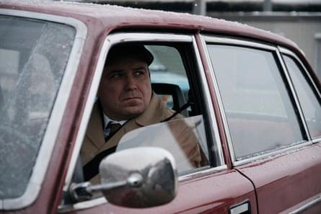
View image in fullscreen
As Graham Anderson in Honey. Photograph: BBC/Sid Gentle Films
Kinnear puts the kettle on and makes us tea. “I really like acting,” he tells me. The way he says it, with the whispered intensity of a confession, makes me laugh. What he loves about Graham’s play is that at its heart it has the biggest of questions – what makes for a good life, and how can we ensure most people have the opportunity to have one? It’s something he’s concerned himself with since childhood, though he might not have realised it at the time. “Even before my dad died, people thought I was an unusually oldish soul.” Kinnear says that as a little boy he felt like a 40-year-old. It’s not surprising, looking back.
He was 10 when his father died. His mother, the actor Carmel Cryan, was left to bring up three children, including his profoundly disabled sister Karina. His childhood was split in two – before and after Roy’s death. He tells me about early memories of accompanying his father to child-friendly TV shows on which Roy was guesting. “I went to the recording of Roland Rat with Dad. Enjoyed that. The Sooty Show – enjoyed that, too. Give us a Clue – lovely.” He could see how much his father was adored, and it made him so proud.
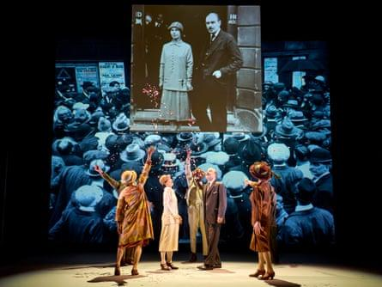
View image in fullscreen
Natalia Osipova, Rory Kinnear (second from right) and other cast members in The Standard of Living by James Graham at Theatre Royal Haymarket in London. Photograph: credit Manuel Harlan
After his father died, he got on with life – winning a scholarship to the independent school St Paul’s, excelling in music and acting, and sailing through exams thanks to his photographic memory. He says he felt he was sustained by Roy, who had lost his own father at a young age in the workplace. Kinnear’s paternal grandfather, Roy Sr, was a renowned Scottish rugby player, who represented Britain at both union and league. In 1942, at the age of 38, Roy Sr died during a match while playing for the RAF.
Did Roy, who was eight when Roy Sr died, ever talk about his father? “I remember him talking about him once, and he welled up.” A few years ago, Kinnear discovered how different it had been for his father after Roy Sr died, when his aunt told him that they were ordered not to discuss it. “My dad and his sister, my aunt, didn’t see my granny for two weeks because she was organising the funeral and then they were told you’re going to meet your mum at the station and then go back up to Scotland from Wigan to start a new life. And they were told: ‘Don’t mention your dad, don’t upset your mum.”
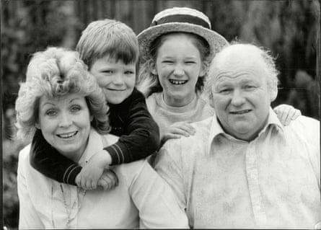
View image in fullscreen
Rory Kinnear in 1983 with his mother Carmel, his father Roy and his sister Kirsty. Photograph: David O’Neil/ANL/Shutterstock
Kinnear starts shaking with tears. He looks embarrassed and smiles. “It still makes me cry. And they’re just sitting on the train with my granny, and my dad’s eight and my aunt’s 10, and they’re looking out of the window trying not to mention anything. Then after about half an hour my granny goes: ‘So how have you all been since …’ and stops. And they lean forward: ‘Since what, Mum? Since what?’ And she finally says: ‘Since your father died.’” And that was that. His grandad’s death was done and dusted.
Kinnear’s grief at his own father’s death didn’t hit him for years. “By the time I was 16, I was beginning to be sad.” He was also angry because his father had died in such a stupid, unnecessary way. What went wrong? “He shouldn’t have been on the horse. The stuntmen refused to do it. It was a cobbled bridge in Spain. Someone said ‘You can’t put horses on cobbled bridges, what are you doing?’ They looked as if they were going to lose the day, so it was agreed that they’d just put some sand down and get the actors to do it.”
After his death, Kinnear’s mother discovered a letter that Roy hadn’t had time to send. “He’d written to my mum: ‘Just off to do a scene that the stuntmen said was too dangerous to do, so wish me good luck.’ It was also a hospital fuck-up. He broke his pelvis. He shouldn’t have died. He just needed a blood transfusion.” The family sued producer Pierre Spengler, director Richard Lester and the production company Falcon Films for negligence, and were awarded £650,000 in damages plus costs.
I ask Kinnear if knowing his father had gone through the same thing helped with his grief. He nods. “I went hand in hand into my grief with his grief. I felt supported and still do.” He wipes away a tear. “I’m a blubber,” he says apologetically. It also helped that he knew Roy had emerged from his grieving intact. “What I was going through he had done, and he’d become a lovely man.”
He thinks the tragedies changed them both in the same way. “There was a sense that he was unmoved by the little stuff because he had been given the big picture early. And I was given the big picture early, too. And that is in some ways a great gift.” What counts as the little stuff? “We didn’t sweat about the minutiae, the tedious irritabilities of life.”
It’s difficult to blub when you’re on the trumpet. A brass blubber, that would be a great party trick
Classical music proved a great solace, he says. When he discovered Mozart’s Dies Irae from his Requiem, he also discovered how to mourn. “I couldn’t believe how much it spoke to me.” He had played trumpet since he was four, but now he learned the piano to help to release his emotions. Did the trumpet not do the trick? He laughs. “It’s difficult to blub when you’re on the trumpet. A brass blubber, that would be a great party trick. On the tuba!” I can sense him choreographing the scene in his head as we talk.
He went on to study English literature at the University of Oxford. Did he enjoy it? “I didn’t love it, if I’m honest.” It’s not as if he wasn’t used to privilege. He’d come straight from St Paul’s, after all. But this was different, he says. “Everybody seemed to know what the plan was. I felt everyone had inherited the plan.” What was it? “Be in politics or law or business. And there was also a readiness to accept the historical tropes of the place, whether it be the rivalry between colleges or what you should do on this particular day because it’s been done for 500 years!”
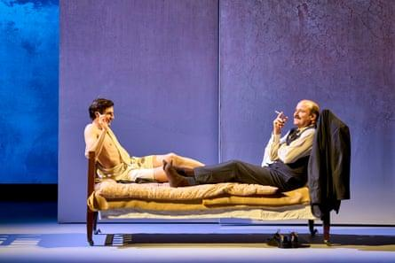
View image in fullscreen
With Luke Cinque White in The Standard of Living. Photograph: Manuel Harlan
From Oxford, he went to the drama school Lamda (the London Academy of Music and Dramatic Art), where his mother had studied, and he couldn’t have been happier. “I realised I love working with other people, I loved having my day structured by someone else, so I instantly knew this is where I should be. You work off other people’s energies. That is what acting is. You are just searching within yourself doing a degree like English, whereas acting feels like a communal pursuit.”
Like Roy, he went from drama school to the Royal Shakespeare Company (RSC), and before long TV opportunities came along. By his early 30s, he had played Hamlet at the National Theatre, hogged the headlines as pig-fucking prime minister Michael Callow in Charlie Brooker’s Black Mirror, and written The Herd, a play about the 21st birthday party of a man with profounddisabilities. In 2017, he added another feather to his bow, directing the world premiere of Ryan Wigglesworth’s opera A Winter’s Tale.
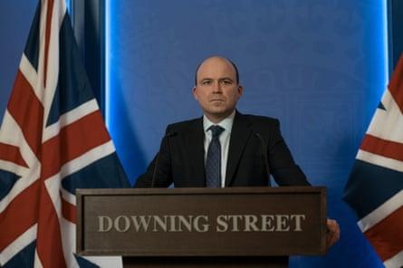
View image in fullscreen
As Nicol Trowbridge in The Diplomat. Photograph: Idris Solomon/Netflix
He says he’s not quite as work obsessed as he was in his early years, but you wouldn’t know it. In 2023, he joined forces with his real-life partner, the actor Pandora Colin in the Netflix drama The Diplomat: she played his wife, Lydia. He and Colin have been together for 20 years, recently had a civil partnership, and have two children, aged 15 and 12. Colin is the daughter of real-life diplomat David Ormsby-Gore who proposed to Jackie Kennedy (before marrying Colin’s mother) and died from injuries sustained in a car crash when she was only 12.
Kinnear is perhaps best known as Bill Tanner from the Bond films. I know very little about James Bond, I say. Me too, he replies with a grin. “I hadn’t seen Bond films before doing them. It wasn’t something I watched. But I’ve enjoyed being in them, and it’s a nice night out to see the premiere! It’s good fun.” He has been in four Bond films, three of them as chief of staff to Judi Dench’s M.
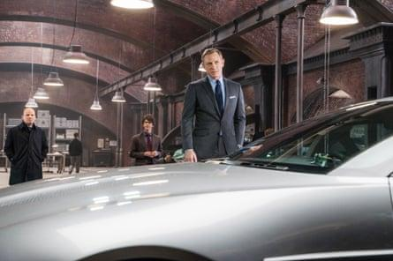
View image in fullscreen
Spooked … Kinnear, Ben Whishaw and Daniel Craig in Spectre. Photograph: Courtesy/Rex Shutterstock
Is it true that Dench is his godmother? Not quite, he says. “Her husband, Michael [Williams], was my godfather. He and my dad became great mates when they were at the RSC together. I didn’t know him that well before, but when Dad died he really upped his game. Then when I was working on the Bond films with Judi, it was great not to be cowed by the legend that is, and also to be able to have those shared memories.”
He looks at a rotating deluxe Scrabble board in front of us. “She was a big Scrabble player. We played quite a bit.” A couple of days before Kinnear and I meet Dench announced that her sight was now too poor for her to work. Such sad news, he says. “Talk about people who love to act! Also, her extraordinary recall. We used to occasionally play a game where I’d give her a line from Shakespeare and see if she knew the next one. Even from roles she hadn’t played. She just knows the work inside out. I can’t remember a role two months after I’ve finished. It just goes.”
Karina wanted to go on the fastest fairground rides that we were frightened to go on. She would just be laughing her head off as we were screaming
Kinnear loves words. It was obvious when he wrote about Karina for the Guardian after she died from Covid in 2020 aged 48. One piece was a beautiful tribute in which he said her kindness remained his anchor. Anotherwas also beautiful but seared with rage after he discovered that the day he, his mother and younger sister gathered for Karina’s socially distanced funeral, Boris Johnson was indulging in a lockdown party.
What was Karina like? “Oh!” His eyes light up. “She was someone who laughed a lot. And each laugh had a slightly different meaning. As a non-verbal adult, that was her means of communication. She loved noisy things, she loved whacking things. Although her arms were quite stiff she loved to whack down on a drum, and a tambourine. She loved being pushed particularly fast in her wheelchair, and when she was younger she wanted to go on the fastest fairground rides that we were frightened to go on. She would just be laughing her head off as we were screaming.” He smiles through the memories. Throughout the day, he says, the house would be filled with Karina’s music (nursery rhymes and Abba) and when her nurses left after their shift, they would be whistling her songs.
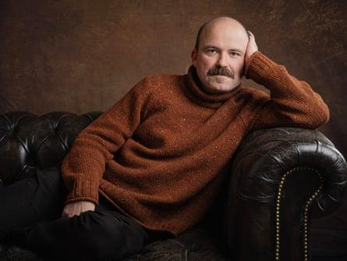
View image in fullscreen
Master of understatement … Rory Kinnear. Photograph: Linda Nylind/The Guardian
He talks about the heroism of his mother, who not only brought up Karina but also bought a house and turned it into a home for others with profound disabilities. He says Karina politicised him. “I would see that my mum’s life as a principal caregiver was at the mercy of the decisions being made elsewhere.” Does he have confidence in Andy Burnham’s proposed social care service? “Yes, at least it’s being talked about. He’s only doing it because people are crying out for it.”
So much change is needed, he says. Not least in his own industry. He assumed that safety on film sets would have been revolutionised since his father’s death, but he discovered it hasn’t been. He is a patron of the Mark Milsome Foundation, named after the award-winning cameraman killed in 2017 when a car stunt went wrong on the Netflix and BBC drama Black Earth Rising. “The industry’s predicated on the hope of the worst not happening rather than ensuring that the worst is eliminated.” Today, cast and crew are still under pressure to cut corners, he says.
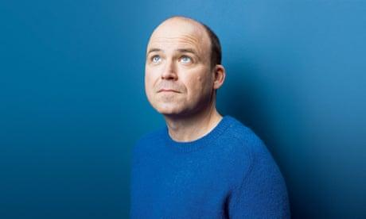
Rory Kinnear: ‘I congratulate everyone who is on the brink of baldness’
Read more
Has that happened to him? “Yay!” he says as if it’s a ridiculous question. And has he resisted the pressure? Yes, he says, but he’s in a stronger position than most. “If someone had the same qualms about safety that I could see, they might not have had the courage to say it or the lifetime experience to know that you can say no.” Has he been asked to compromise his safety more than once? “It’s probably happened four or five times. In one of my first jobs, a biblical epic, we were filming in the desert and they said today we’re going to have you riding at the top of this hill, and I was like: ‘I’m going to need riding lessons.’ They said: ‘The horse will just be walking,’ and I was like: ‘What if the horse starts going faster? I don’t feel comfortable with that.’ And it was like: ‘Mate, it’s your first job, fucking wind your neck in.’”
When he told the producers his father had died riding a horse on location they finally backed down. “I guess I have the cards to play to say no shot is worth anything as important as human life. None of it is worth what happened to me.” So you say what happened to you, not your father? “Yes because I’m standing in front of them and I’ve lived 40 years of this accident affecting my life. I’ve made it work in the best way for me, but both Dad and I would have preferred it not have happened.” Kinnear is a master of understatement.
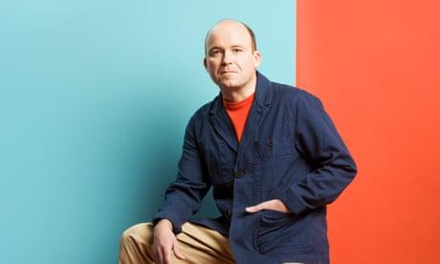
‘The umbrella of kindness carries on’: Rory Kinnear on death, fairness and Judi Dench
Read more
He found it devastating in the pandemic how disabled people such as Karina were written off; their lives, and deaths, dismissed as insignificant. That’s why he was so keen to write about her. “A lot of her life was missing out on stuff or having things prodded or poked, but she was joyful and remained joyful.” Karina taught him so much, he says. “The most cherished relationships we have are the ones that most surprised us or changed us in a way we didn’t expect. Karina cherished joy despite getting the shitty end of the stick, which is a good lesson for life in itself, but she also made people around her so much happier.”
Kinnear thinks of Roy Sr who he never got to meet, Roy who was only there for his first 10 years and Karina who he knew best. They might have died young, but all three enriched, and continue to enrich, the lives of those around them. It goes back to the issue he’s spent a lifetime pondering. And he asks himself the question one last time. “It’s that thing isn’t it, what is a good life?”
Honey is on BBC One and BBC iPlayer from 14 November. The Standard of Living is at Theatre Royal Haymarket, London, until 12 December. Onwards and Sideways will be in UK cinemas from 6 November and on BBC One and BBC iPlayer later this year
You've read 5 articles in the last year
Article count
on
… we have a small favour to ask. Tens of millions have placed their trust in the Guardian’s fearless journalism since we started publishing more than 200 years ago, turning to us in moments of crisis, uncertainty, solidarity and hope. More than 1.5 million supporters, from 180 countries, now power us financially – keeping us open to all, and fiercely independent. Will you make a difference and support us too?
Unlike many others, the Guardian has no shareholders and no billionaire owner. Just the determination and passion to deliver high-impact global reporting, always free from commercial or political influence. Reporting like this is vital for democracy, for fairness and to demand better from the powerful.
And we provide all this for free, for everyone to read. We do this because we believe in information equality. Greater numbers of people can keep track of the global events shaping our world, understand their impact on people and communities, and become inspired to take meaningful action. Millions can benefit from open access to quality, truthful news, regardless of their ability to pay for it.
Whether you give a little or a lot, the support of readers like you from Vietnam will power our reporting for the years to come.
We value whatever you can spare. Your support enables greater investment in our most crucial, fearless journalism. Thank you.
Support now

